**18. Table**

<!DOCTYPE html>

<html>

<head>

<title>Lab 18</title>

<style>

table {

border-collapse: collapse;

width: 60%;

margin: 20px;

}

th,

td {

border: 1px solid black;

padding: 8px;

text-align: center;

}

th {

background-color: #f0f0f0;

}

</style>

</head>

<body>

<h2>Student Information</h2>

<table>

<tr>

<th>S.N.</th>

<th>Name</th>

<th>Age</th>

<th>Grade</th>

</tr>

<tr>

<td>1</td>

<td>Aarav Sharma</td>

<td>18</td>

<td>A</td>

</tr>

<tr>

<td>2</td>

<td>Sita Koirala</td>

<td>17</td>

<td>B+</td>

</tr>

<tr>

<td>3</td>

<td>Binod Thapa</td>

<td>19</td>

<td>A-</td>

</tr>

</table>

</body>

</html>

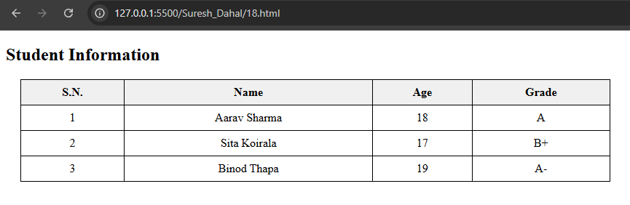

**19. HTML Text Formatting**

<!DOCTYPE html>

<html>

<head>

<title>Lab 19</title>

<style>

table {

width: 90%;

border-collapse: collapse;

margin: 20px auto;

}

th,

td {

border: 1px solid #000;

padding: 8px;

text-align: left;

}

th {

background: #f2f2f2;

}

</style>

</head>

<body>

<h2 style="text-align:center;">HTML Text Formatting Tags</h2>

<table>

<tr>

<th>Tag</th>

<th>Description</th>

<th>Example Output</th>

</tr>

<tr>

<td>&lt;b&gt;</td>

<td>Bold text</td>

<td><b>This is bold</b></td>

</tr>

<tr>

<td>&lt;strong&gt;</td>

<td>Important text (bold)</td>

<td><strong>This is strong</strong></td>

</tr>

<tr>

<td>&lt;i&gt;</td>

<td>Italic text</td>

<td><i>This is italic</i></td>

</tr>

<tr>

<td>&lt;em&gt;</td>

<td>Emphasized text (italic)</td>

<td><em>This is emphasized</em></td>

</tr>

<tr>

<td>&lt;u&gt;</td>

<td>Underlined text</td>

<td><u>This is underlined</u></td>

</tr>

<tr>

<td>&lt;mark&gt;</td>

<td>Marked/highlighted text</td>

<td><mark>This is marked</mark></td>

</tr>

<tr>

<td>&lt;small&gt;</td>

<td>Smaller text</td>

<td><small>This is small</small></td>

</tr>

<tr>

<td>&lt;del&gt;</td>

<td>Deleted text (strikethrough)</td>

<td><del>This is deleted</del></td>

</tr>

<tr>

<td>&lt;ins&gt;</td>

<td>Inserted text (underlined)</td>

<td><ins>This is inserted</ins></td>

</tr>

<tr>

<td>&lt;sub&gt;</td>

<td>Subscript text</td>

<td>H<sub>2</sub>O</td>

</tr>

<tr>

<td>&lt;sup&gt;</td>

<td>Superscript text</td>

<td>2<sup>3</sup> = 8</td>

</tr>

</table>

</body>

</html>

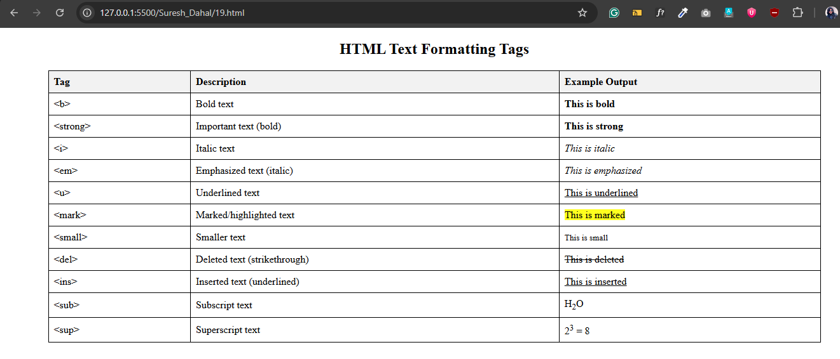

**20. HTML Bullets**

<!DOCTYPE html>

<html>

<head>

<title>Lab 20</title>

<style>

body {

font-family: Arial, sans-serif;

margin: 20px;

}

h2 {

color: #333;

}

</style>

</head>

<body>

<h2>Unordered List (Bullet Points)</h2>

<ul>

<li>Milk</li>

<li>Eggs</li>

<li>Bread</li>

<li>Butter</li> </ul>

<h2>Ordered List (Numbered)</h2>

<ol>

<li>Wake up</li>

<li>Brush teeth</li>

<li>Take a shower</li>

<li>Have breakfast</li>

</ol>

<h2>Description List</h2>

<dl>

<dt>HTML</dt>

<dd>A markup language for creating web pages.</dd>

<dt>CSS</dt>

<dd>A style sheet language used for describing the look of a document.</dd>

<dt>JavaScript</dt>

<dd>A scripting language to add interactivity to web pages.</dd>

</dl>

</body>

</html>

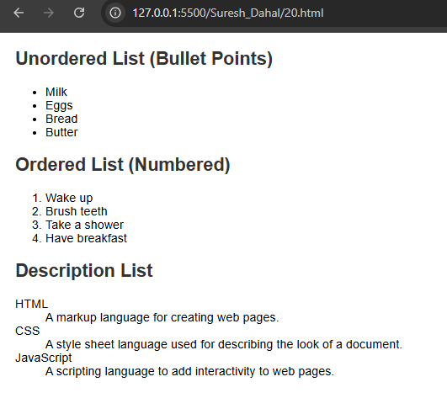

**21. Working with Image**

<!DOCTYPE html>

<html>

<head>

<title>Lab 21</title>

</head>

<body>

<h2>My Favorite Place</h2>

<p>This is an image of a peaceful mountain view:</p>

<img src="https://picsum.photos/500/400" alt="Mountain View" width="400" height="250">

</body>

</html>

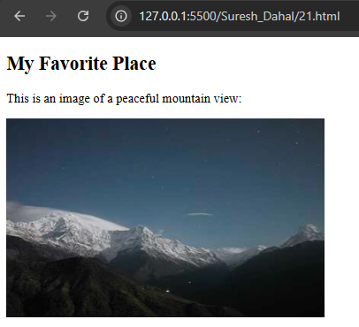

**22. Registration Form**

<!DOCTYPE html>

<html>

<head>

<title>Lab 22</title>

</head>

<body>

<h2>Employee Registration Form</h2>

<form action="#" method="post">

<label for="name">Full Name:</label><br>

<input type="text" id="name" name="name" required><br><br>

<label for="empid">Employee ID:</label><br>

<input type="text" id="empid" name="empid" required><br><br>

<label for="email">Email:</label><br>

<input type="email" id="email" name="email"><br><br>

<label for="department">Department:</label><br>

<input type="text" id="department" name="department"><br><br>

<label for="gender">Gender:</label><br>

<input type="radio" id="male" name="gender" value="Male">

<label for="male">Male</label>

<input type="radio" id="female" name="gender" value="Female">

<label for="female">Female</label><br><br>

<label for="dob">Date of Birth:</label><br>

<input type="date" id="dob" name="dob"><br><br>

<label for="skills">Skills:</label><br>

<input type="checkbox" name="skills" value="HTML"> HTML

<input type="checkbox" name="skills" value="CSS"> CSS

<input type="checkbox" name="skills" value="JavaScript"> JavaScript<br><br>

<label for="address">Address:</label><br>

<textarea id="address" name="address" rows="4" cols="30"></textarea><br><br>

<input type="submit" value="Register">

<input type="reset" value="Clear">

</form>

</body>

</html>

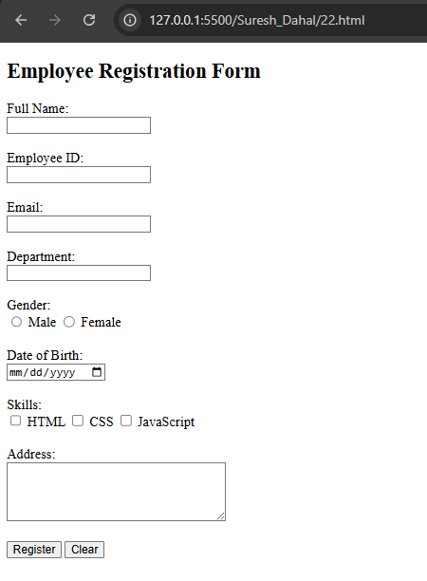

**23. HTML Entities**

<!DOCTYPE html>

<html>

<head>

<title>Lab 23</title>

</head>

<body>

<h1>Welcome to My First Web Page</h1>

<p>This is my first paragraph. I'm learning how to use basic HTML tags to build web pages. It's fun and simple!</p>

<p>This is my second paragraph. HTML helps structure content using tags, and I can already create headings, lists,

and add images.</p>

<h2>Unordered List Example</h2>

<ul>

<li>An unordered list can be specified with the tags &lt;ul&gt; and &lt;/ul&gt;.</li>

<li>An unordered list typically contains a number of list items that can be specified with tags &lt;li&gt; and

&lt;/li&gt;.</li>

<li>After you have created your unordered list, check what happens when you convert it to an ordered list by

replacing the tags.</li>

</ul>

<h2>Image Example</h2>

<img src="https://picsum.photos/300/250" alt="Sample Image" width="300">

</body>

</html>

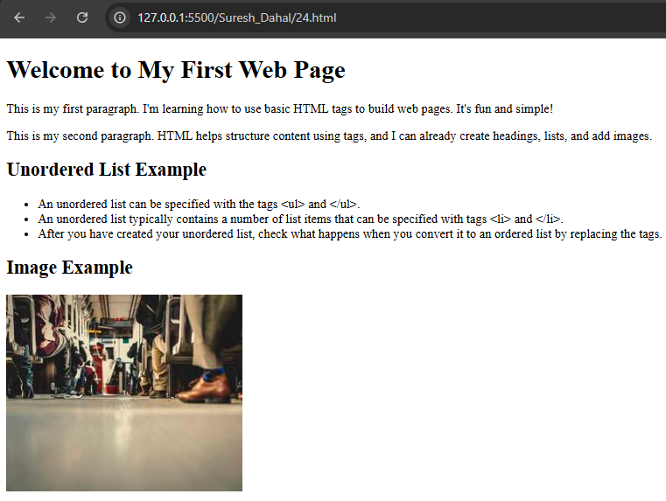

**24. Anchor Link**

<!DOCTYPE html>

<html>

<head>

<title>Another Page</title>

</head>

<body>

<h1>This is Another Page</h1>

<p>Here is hyperlink to the previous page.</p>

<a href="23.html">Click here.</a>

</body>

</html>

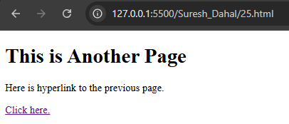

**25. HTML Anchor Title**

<!DOCTYPE html>

<html>

<head>

<title>Another Page</title>

</head>

<body>

<h1>This is Another Page</h1>

<p>Hyperlink with title.</p>

<a href="24.html" title="This page leads you to another page">Click here.</a>

</body>

</html>

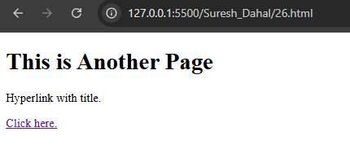

**26. Image as a Link**

<!DOCTYPE html>

<html>

<head>

<title>Another Page</title>

</head>

<body>

<h1>This page has image with link</h1>

<p>Click on the image to go to another page.</p>

<a href="24.html">

<img src="https://picsum.photos/400/300" alt="Sample Image" width="300">

</a>

</body>

</html>

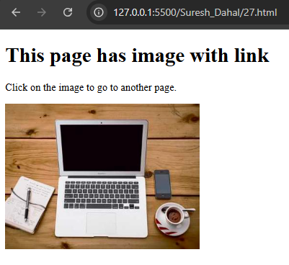

**27. College Website**

**index.html**

<!DOCTYPE html>

<html>

<head>

<title>ABC College - Home</title>

<link rel="stylesheet" href="styles.css">

</head>

<body>

<h1 class="flex">

<img src="logo.jpg" alt="College Logo"

height="60">

ABC College

</h1>

<div class="nav">

<a href="index.html">Home</a>

<a href="academics.html">Academics</a>

<a href="admission.html">Admission</a>

<a href="gallery.html">Gallery</a>

<a href="contact.html">Contact Us</a>

<a href="about.html">About Us</a>

</div>

<div class="section">

<h2>Welcome</h2>

<p>Welcome to ABC College. We offer Arts, Science, and Commerce programs in a supportive learning environment. Explore our courses and vibrant campus life.</p>

<p>Established in 1990, ABC College has been dedicated to providing quality education to students from diverse backgrounds. Our mission is to foster academic excellence, creativity, and social responsibility in every student.</p>

<p>With a team of experienced faculty members and modern facilities, we offer a wide range of undergraduate and postgraduate programs in Arts, Science, and Commerce. Our college emphasizes a holistic learning environment, encouraging students to excel both academically and personally.</p>

</div>

<div class="section">

<h2>College Details</h2>

<p><strong>Established:</strong> 1990</p>

<p><strong>Location:</strong> Kathmandu, Nepal</p>

<p><strong>Contact:</strong> info@abccollege.edu.np | +977-1-1234567</p>

</div>

</body>

</html>

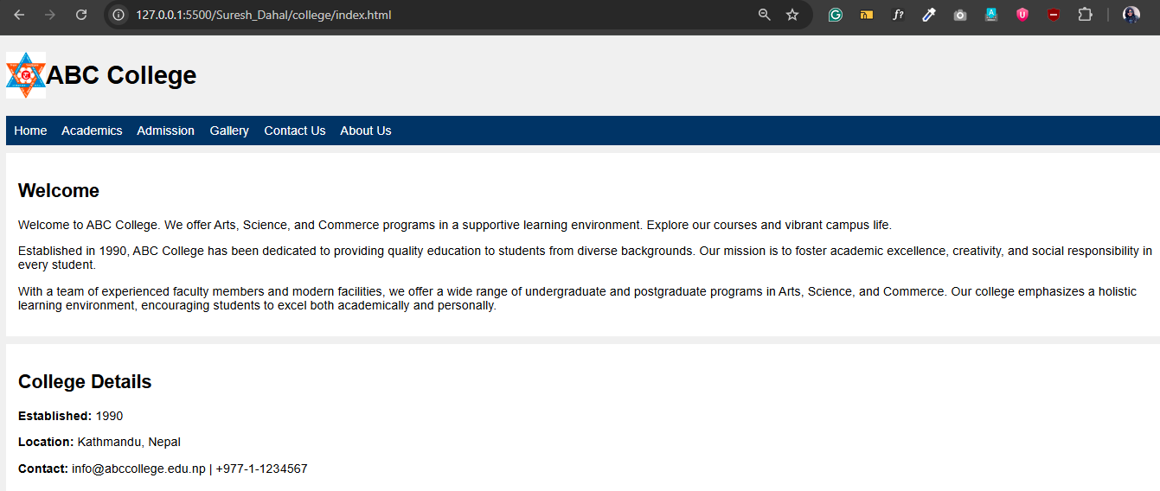

**academics.html**

<div class="section">

<h2>Departments & Courses</h2>

<ul>

<li>Faculty of Humanities and Social Sciences

<ul>

<li><a href="nepali.html">Nepali</a></li>

<li><a href="english.html">English</a></li>

<li><a href="sociology.html">Sociology</a></li>

<li><a href="economics.html">Economics</a></li>

</ul>

</li>

<li>Faculty of Science and Technology

<ul>

<li><a href="physics.html">Physics</a></li>

<li><a href="chemistry.html">Chemistry</a></li>

<li><a href="biology.html">Biology</a></li>

<li>Information Technology

<ol type="a">

<li><a href="cs.html">Computer Science</a></li>

<li><a href="bit.html">BIT</a></li>

</ol>

</li>

</ul>

</li>

<li>Faculty of Management

<ul>

<li><a href="bba.html">BBA</a></li>

<li><a href="bbs.html">BBS</a></li>

<li><a href="mba.html">MBA</a></li>

</ul>

</li>

<li>Faculty of Education

<ul>

<li><a href="bed.html">B.Ed.</a></li>

<li><a href="med.html">M.Ed.</a></li>

</ul>

</li>

</ul>

</div>

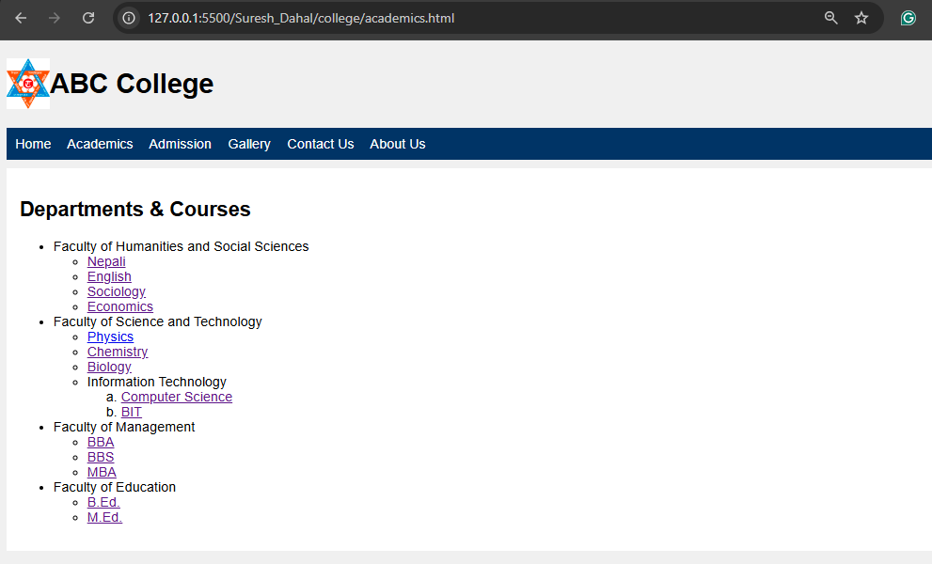

**bit.html**

<div class="section">

<h2>Bachelor of Information Technology (BIT)</h2>

<p>

The BIT program at ABC College is designed to provide students with a strong foundation in information

technology, software engineering, networking, database systems, and web development. Graduates will be

equipped with practical skills and theoretical knowledge to excel in the IT industry.

</p>

<h3>Teachers</h3>

<div class="flex-gap">

<div class="teacher">

<img src="https://randomuser.me/api/portraits/men/45.jpg" alt="Mr. Rajesh Thapa">

<span>Mr. Rajesh Thapa</span>

</div>

<div class="teacher">

<img src="https://randomuser.me/api/portraits/women/44.jpg" alt="Ms. Sita Gurung">

<span>Ms. Sita Gurung</span>

</div>

<div class="teacher">

<img src="https://randomuser.me/api/portraits/men/46.jpg" alt="Mr. Rajesh Thapa">

<span>Mr. Arjun Thapa</span>

</div>

<div class="teacher">

<img src="https://randomuser.me/api/portraits/women/47.jpg" alt="Ms. Sita Gurung">

<span>Ms. Reema Shilpakar</span>

</div>

</div>

<h3>Timetable</h3>

<table>

<tr>

<th>Day</th>

<th>11:00-12:00</th>

<th>12:00-1:00</th>

<th>1:00-2:00</th>

<th>2:00-2:30</th>

<th>2:30-3:30</th>

<th>3:30-4:30</th>

</tr>

<tr>

<td>Monday</td>

<td rowspan="6">WEB-I</td>

<td rowspan="6">AI</td>

<td rowspan="6">SAD</td>

<td rowspan="6">Break</td>

<td rowspan="6">NDC</td>

<td rowspan="6">OR</td>

</tr>

<tr>

<td>Tuesday</td>

</tr>

<tr>

<td>Wednesday</td>

</tr>

<tr>

<td>Thursday</td>

</tr>

<tr>

<td>Friday</td>

</tr>

</table>

</div>

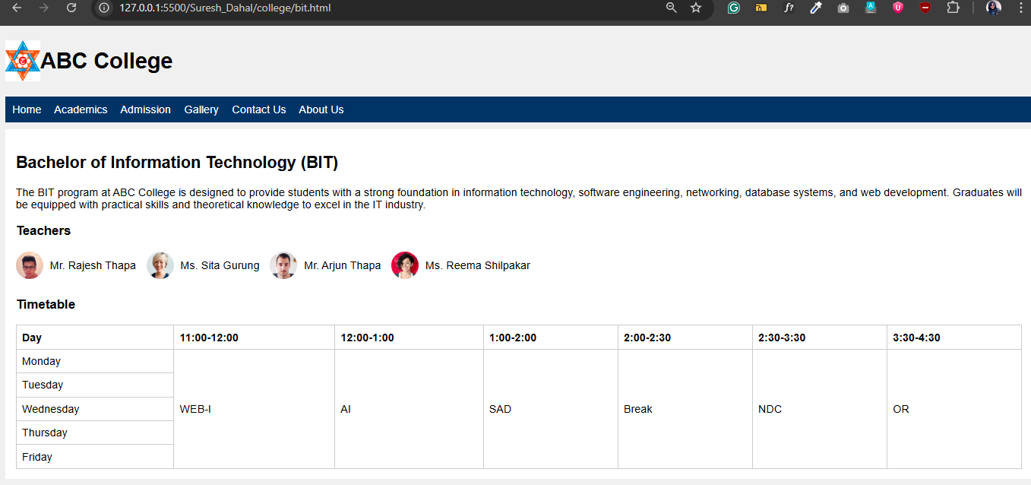

**physics.html**

<div class="section">

<h2>Physics</h2>

<p>

The Physics course covers fundamental concepts such as mechanics, thermodynamics, electromagnetism, optics,

and modern physics. Students develop analytical and problem-solving skills through theoretical lessons and

practical experiments.

</p>

<h3>Teachers</h3>

<div class="flex-gap">

<div class="teacher">

<img src="https://randomuser.me/api/portraits/men/45.jpg" alt="Mr. Prakash Sharma">

<span>Mr. Prakash Sharma</span>

</div>

<div class="teacher">

<img src="https://randomuser.me/api/portraits/women/44.jpg" alt="Ms. Sita Gurung">

<span>Ms. Sita Gurung</span>

</div>

<div class="teacher">

<img src="https://randomuser.me/api/portraits/men/46.jpg" alt="Mr. Arjun Thapa">

<span>Mr. Arjun Thapa</span>

</div>

<div class="teacher">

<img src="https://randomuser.me/api/portraits/women/47.jpg" alt="Ms. Reema Shilpakar">

<span>Ms. Reema Shilpakar</span>

</div>

</div>

<h3>Timetable</h3>

<table>

<tr>

<th>Day</th>

<th>11:00-12:00</th>

<th>12:00-1:00</th>

<th>1:00-2:00</th>

<th>2:00-2:30</th>

<th>2:30-3:30</th>

<th>3:30-4:30</th>

</tr>

<tr>

<td>Monday</td>

<td rowspan="6">Mechanics</td>

<td rowspan="6">thermodynamics</td>

<td rowspan="6">Optics</td>

<td rowspan="6">Break</td>

<td rowspan="6">Statistics</td>

<td rowspan="6">Calculus</td>

</tr>

<tr>

<td>Tuesday</td>

</tr>

<tr>

<td>Wednesday</td>

</tr>

<tr>

<td>Thursday</td>

</tr>

<tr>

<td>Friday</td>

</tr>

</table>

</div>

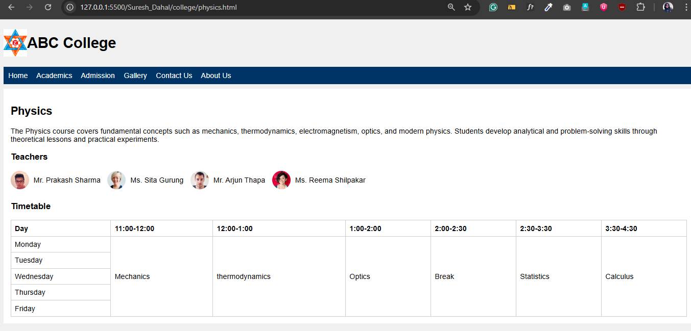

**nepali.html**

<div class="section">

<h2>Nepali</h2>

<p>Nepali course explores classical and contemporary works in Nepali language, enhancing students' understanding of cultural and literary heritage.</p>

<h3>Teachers</h3>

<div class="flex-gap">

<div class="teacher">

<img src="https://randomuser.me/api/portraits/men/45.jpg" alt="Mr. Rajesh Thapa">

<span>Mr. Rajesh Thapa</span>

</div>

<div class="teacher">

<img src="https://randomuser.me/api/portraits/women/44.jpg" alt="Ms. Sita Gurung">

<span>Ms. Sita Gurung</span>

</div>

<div class="teacher">

<img src="https://randomuser.me/api/portraits/men/46.jpg" alt="Mr. Rajesh Thapa">

<span>Mr. Arjun Thapa</span>

</div>

<div class="teacher">

<img src="https://randomuser.me/api/portraits/women/47.jpg" alt="Ms. Sita Gurung">

<span>Ms. Reema Shilpakar</span>

</div>

</div>

<h3>Timetable</h3>

<table>

<tr>

<th>Day</th>

<th>11:00-12:00</th>

<th>12:00-1:00</th>

<th>1:00-2:00</th>

<th>2:00-2:30</th>

<th>2:30-3:30</th>

<th>3:30-4:30</th>

</tr>

<tr>

<td>Monday</td>

<td rowspan="5">व्याकरण (Grammar)</td>

<td>निबन्ध लेखन (Essay Writing)</td>

<td rowspan="5">कविता (Poetry)</td>

<td rowspan="5">Break</td>

<td rowspan="5">साहित्य (Literature)</td>

<td rowspan="5">पुनरावृत्ति (Revision)</td>

</tr>

<tr>

<td>Tuesday</td>

<td>पठन (Reading)</td>

</tr>

<tr>

<td>Wednesday</td>

<td>निबन्ध लेखन (Essay Writing)</td>

</tr>

<tr>

<td>Thursday</td>

<td>निबन्ध लेखन (Essay Writing)</td>

</tr>

<tr>

<td>Friday</td>

<td>निबन्ध लेखन (Essay Writing)</td>

</tr>

</table>

</div>

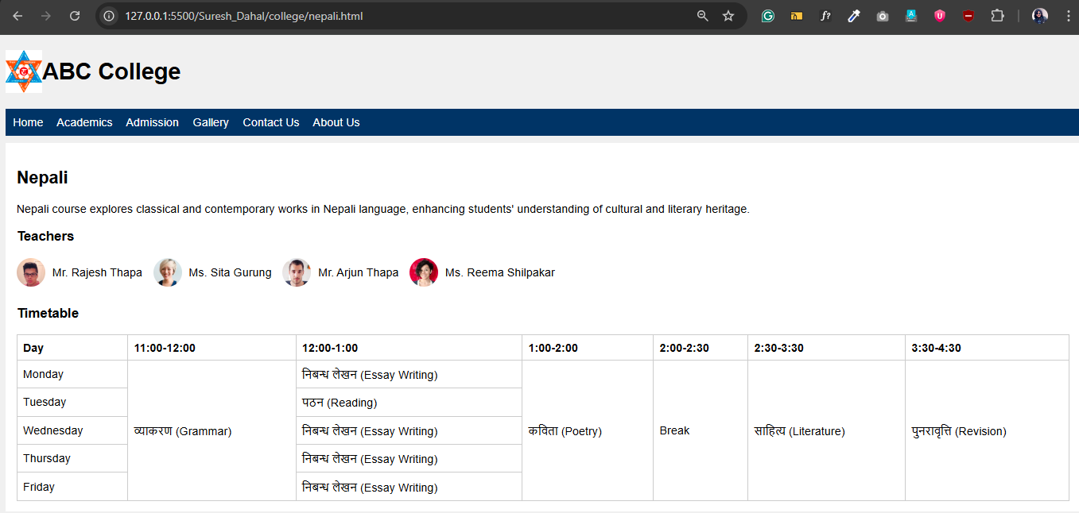

**bba.html**

<div class="section">

<h2>BBA</h2>

<p>

The Bachelor of Business Administration (BBA) program at ABC College equips students with essential business

and management skills. The curriculum covers areas such as organizational behavior, business communication,

accounting, marketing, and entrepreneurship, preparing graduates for leadership roles in the corporate

world.

</p>

<h3>Teachers</h3>

<div class="teacher">

<img src="https://randomuser.me/api/portraits/women/45.jpg" alt="Ms. Priya Shrestha">

<span>Ms. Priya Shrestha</span>

</div>

<div class="teacher">

<img src="https://randomuser.me/api/portraits/men/52.jpg" alt="Mr. Rajesh Karki">

<span>Mr. Rajesh Karki</span>

</div>

<h3>Timetable</h3>

<table>

<tr>

<th>Day</th>

<th>Time</th>

<th>Topic</th>

</tr>

<tr>

<td>Monday</td>

<td>10:00 AM - 12:00 PM</td>

<td>Organizational Behavior</td>

</tr>

<tr>

<td>Wednesday</td>

<td>10:00 AM - 12:00 PM</td>

<td>Business Communication</td>

</tr>

<tr>

<td>Friday</td>

<td>10:00 AM - 12:00 PM</td>

<td>Marketing Management</td>

</tr>

</table>

</div>

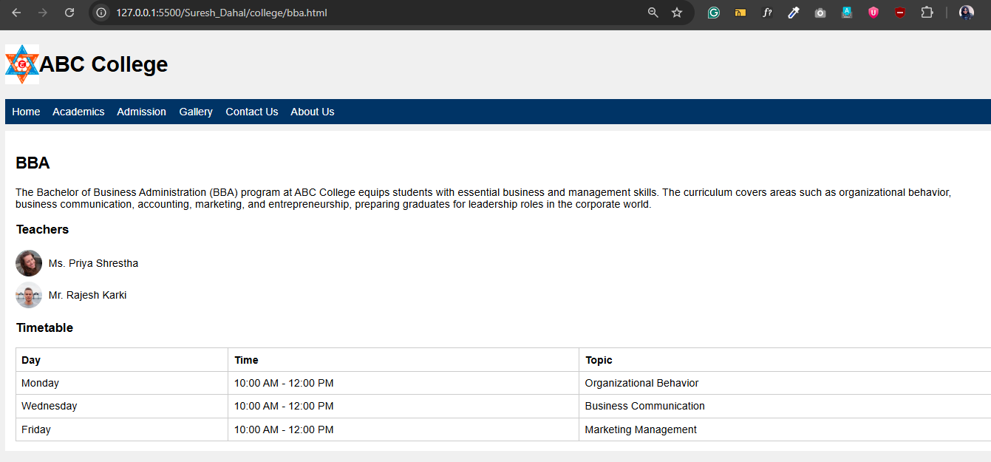

**admission.html**

<div class="form-container">

<h2>Student Admission Form</h2>

<form action="#" method="post">

<table>

<tr>

<td><label for="fullname">Full Name:</label></td>

<td><input type="text" id="fullname" name="fullname" required></td>

<td><label for="dob">Date of Birth:</label></td>

<td><input type="date" id="dob" name="dob" required></td>

</tr>

<tr>

<td><label for="gender">Gender:</label></td>

<td>

<select id="gender" name="gender" required>

<option value="" disabled selected>Select gender</option>

<option value="male">Male</option>

<option value="female">Female</option>

<option value="other">Other</option>

</select>

</td>

<td><label for="email">Email Address:</label></td>

<td><input type="email" id="email" name="email" required></td>

</tr>

<tr>

<td><label for="phone">Phone Number:</label></td>

<td><input type="tel" id="phone" name="phone" pattern="[0-9]{10}" placeholder="10-digit number"

required></td>

<td><label for="marks">High School Marks (%):</label></td>

<td><input type="number" id="marks" name="marks" min="0" max="100" required></td>

</tr>

<tr>

<td><label for="department">Department to Apply:</label></td>

<td>

<select id="department" name="department" required>

<option value="" disabled selected>Select department</option>

<option value="arts">Arts</option>

<option value="science">Science</option>

<option value="commerce">Commerce</option>

</select>

</td>

<td><label for="course">Course:</label></td>

<td>

<select id="course" name="course" required>

<option value="" disabled selected>Select course</option>

<option value="english">English</option>

<option value="sociology">Sociology</option>

<option value="computer_science">Computer Science</option>

<option value="biology">Biology</option>

<option value="accounting">Accounting</option>

<option value="business_studies">Business Studies</option>

</select>

</td>

</tr>

<tr>

<td class="address-label"><label for="address">Address:</label></td>

<td class="address-input" colspan="3"><textarea id="address" name="address" rows="3"

required></textarea></td>

</tr>

<tr>

<td><label>Are you a resident?</label></td>

<td>

<input type="radio" id="resident_yes" name="resident" value="yes" required>

<label for="resident_yes">Yes</label><br>

<input type="radio" id="resident_no" name="resident" value="no">

<label for="resident_no">No</label>

</td>

<td>

<label for="agree">Agree to terms:</label>

<input type="checkbox" id="agree" name="agree" required>

</td>

</tr>

<tr>

<td colspan="4" style="text-align:right;">

<input type="submit" value="Submit Application">

</td>

</tr>

</table>

</form>

</div>

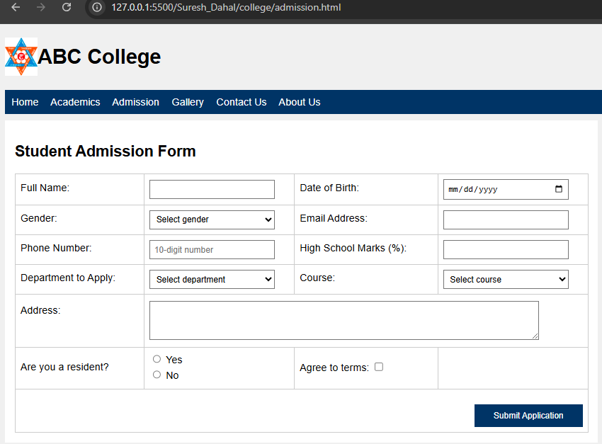

**gallery.html**

<div class="gallery-container">

<h2>College Gallery</h2>

<table>

<tr>

<td><img src="https://picsum.photos/id/1011/360/240" alt="Campus Image 1"><br>Campus Grounds

</td>

<td><img src="https://picsum.photos/id/1012/360/240" alt="Students Image 1"><br>Students

at Library</td>

<td><img src="https://picsum.photos/id/1014/360/240" alt="Event Image 1"><br>Science Fair

</td>

<td><img src="https://picsum.photos/id/1020/360/240" alt="Sports Image 1"><br>Sports Day

</td>

</tr>

<tr>

<td><img src="https://picsum.photos/id/1024/360/240" alt="Campus Image 2"><br>Main Building

</td>

<td><img src="https://picsum.photos/id/1025/360/240" alt="Students Image 2"><br>Classroom

Session</td>

<td><img src="https://picsum.photos/id/1033/360/240" alt="Event Image 2"><br>Art Exhibition

</td>

<td><img src="https://picsum.photos/id/1035/360/240" alt="Sports Image 2"><br>Football Match

</td>

</tr>

</table>

</div>

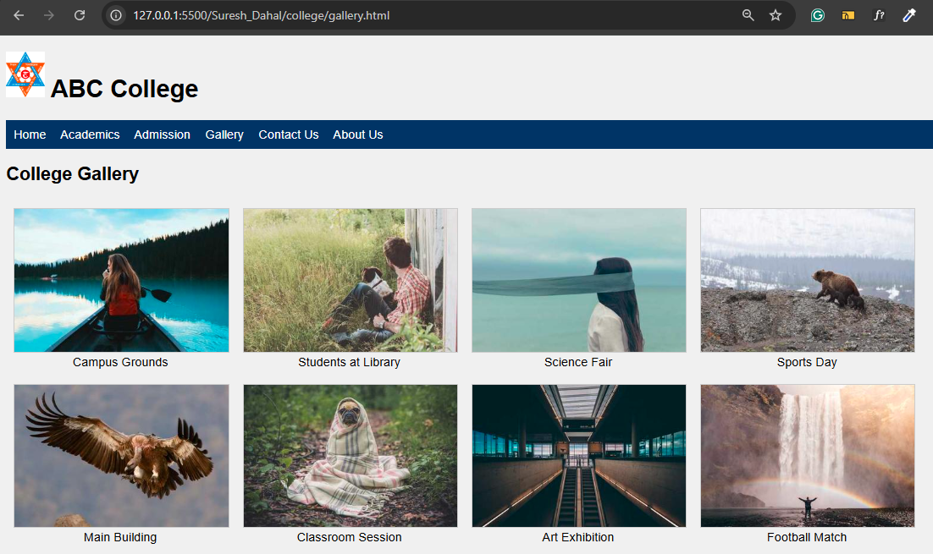

**contact.html**

<div class="content">

<h2>Contact Us</h2>

<p>If you have any questions or need further information, please fill out the form below or use the contact

details provided.</p>

<table>

<tr>

<td>

<form>

<table>

<tr>

<td><label for="name">Name:</label></td>

<td><input type="text" id="name" name="name" required></td>

<td><label for="email">Email:</label></td>

<td><input type="email" id="email" name="email" required></td>

</tr>

<tr>

<td><label for="phone">Phone:</label></td>

<td><input type="tel" id="phone" name="phone"></td>

<td><label for="subject">Subject:</label></td>

<td><input type="text" id="subject" name="subject"></td>

</tr>

<tr>

<td><label for="message">Message:</label></td>

<td colspan="3"><textarea id="message" name="message" rows="4" required></textarea></td>

</tr>

<tr>

<td colspan="4" style="text-align:center;">

<input type="submit" value="Send Message">

</td>

</tr>

</table>

</form>

</td>

</tr>

<tr>

<td>

<h3>College Address</h3>

<p>123 College Road,<br>City, State, ZIP Code</p>

<h3>Phone</h3>

<p>+1 234 567 8900</p>

<h3>Email</h3>

<p>info@abccollege.edu</p>

</td>

</tr>

</table>

</div>

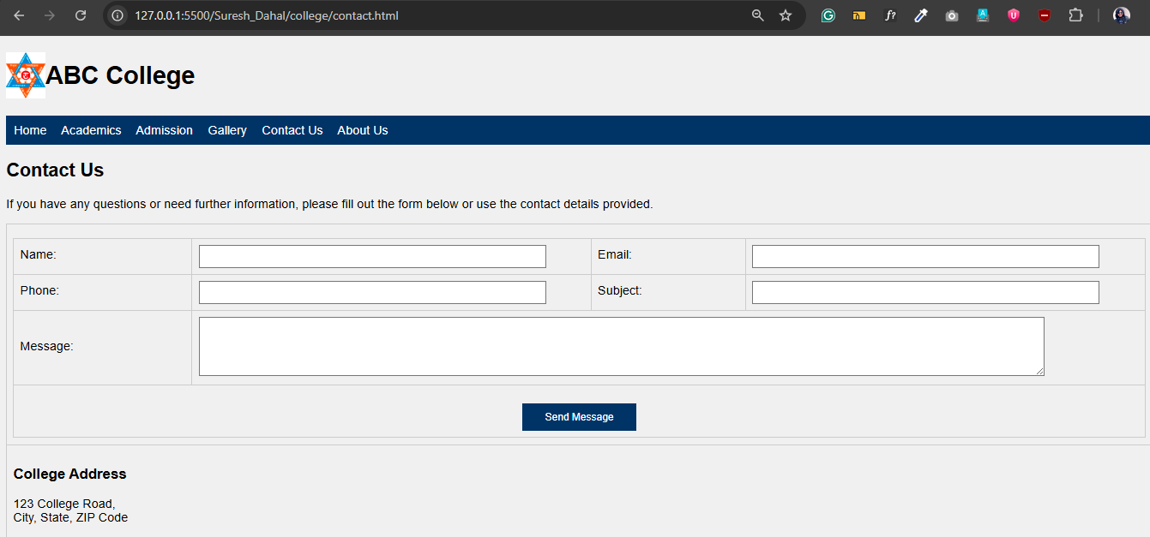

**about.html**

<div class="flex">

<div>

<h2>About ABC College</h2>

<p>Established in 1990, ABC College has been dedicated to providing quality education to students from

diverse

backgrounds. Our mission is to foster academic excellence, creativity, and social responsibility in

every

student.</p>

<p>With a team of experienced faculty members and modern facilities, we offer a wide range of undergraduate

and

postgraduate programs in Arts, Science, and Commerce. Our college emphasizes a holistic learning

environment, encouraging students to excel both academically and personally.</p>

<p>ABC College is committed to community engagement, research, and innovation. We believe in nurturing

future

leaders who contribute positively to society.</p>

</div>

<img src="college.jpg " alt="College Image" style="border-radius:8px; max-width:300px;">

</div>

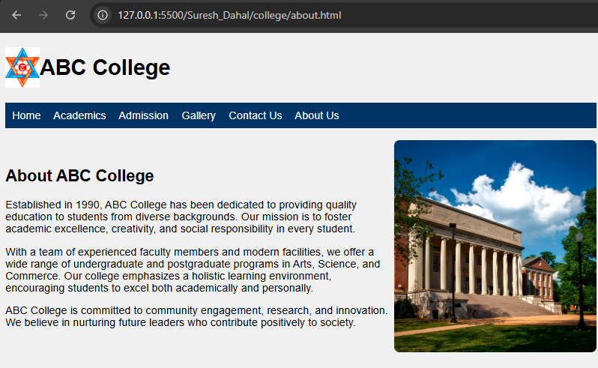

**Style.css**

body {

background-color: #f0f0f0;

font-family: sans-serif;

}

.nav {

background-color: #003366;

padding: 10px;

}

.nav a {

color: white;

text-decoration: none;

margin-right: 15px;

}

.section {

background-color: white;

padding: 15px;

margin-top: 10px;

}

.flex {

display: flex;

align-items: center;

}

table {

width: 100%;

border-collapse: collapse;

margin-top: 10px;

}

.flex-gap {

display: flex;

flex-wrap: wrap;

gap: 15px;

}

table,

th,

td {

border: 1px solid #ccc;

}

th,

td {

padding: 8px;

text-align: left;

}

.teacher {

display: flex;

align-items: center;

margin-bottom: 8px;

}

.teacher img {

height: 40px;

width: 40px;

border-radius: 50%;

margin-right: 10px;

}

label {

display: inline-block;

margin-bottom: 5px;

}

input[type="text"],

input[type="email"],

input[type="date"],

input[type="tel"],

input[type="number"],

select,

textarea {

width: 90%;

padding: 6px;

box-sizing: border-box;

}

textarea {

resize: vertical;

}

.form-container {

background-color: white;

padding: 15px;

margin-top: 10px;

width: 900px;

}

input[type="submit"] {

background-color: #003366;

color: white;

border: none;

padding: 10px 30px;

cursor: pointer;

margin-top: 15px;

}

.address-label {

vertical-align: top;

padding-top: 15px;

}

.address-input {

padding-top: 10px;

}

.gallery-container {

width: 80%;

}

.gallery-container img {

width: 100%;

object-fit: cover;

border: 1px solid #ccc;

}

caption {

font-weight: bold;

margin-bottom: 10px;

}

**28. Tourism Website**

**Index.html**

<!DOCTYPE html>

<html>

<head>

<title>Explore Kathmandu</title>

</head>

<body>

<header>

<img src="https://upload.wikimedia.org/wikipedia/commons/9/9b/Flag_of_Nepal.svg" alt="Nepal Logo" class="logo">

<h1>Explore Kathmandu</h1>

</header>

<nav>

<a href="index.html">Home</a>

<a href="heritage.html">Heritage</a>

<a href="hotel.html">Hotel Booking</a>

<a href="gallery.html">Gallery</a>

<a href="about.html">About</a>

</nav>

<div class="content">

<p>

Kathmandu, the capital city of Nepal, is a vibrant blend of ancient heritage and modern culture.

Home to stunning temples, bustling markets, and rich history, Kathmandu is a gateway to the Himalayas

and a treasure trove of UNESCO World Heritage Sites.

</p>

<p>

From the majestic Swayambhunath Stupa to the intricately carved Patan Durbar Square, every corner

of the city whispers tales of centuries gone by. Whether you're a spiritual seeker, history enthusiast,

or adventurer, Kathmandu welcomes you with open arms and timeless charm.

</p>

<p>

Use the navigation bar above to explore the city's ancient heritage sites, book hotels, or browse

the photo gallery for a visual taste of your next adventure.

</p>

<a href="heritage.html" class="btn">

Discover Heritage Sites

</a>

</div>

</body>

</html>

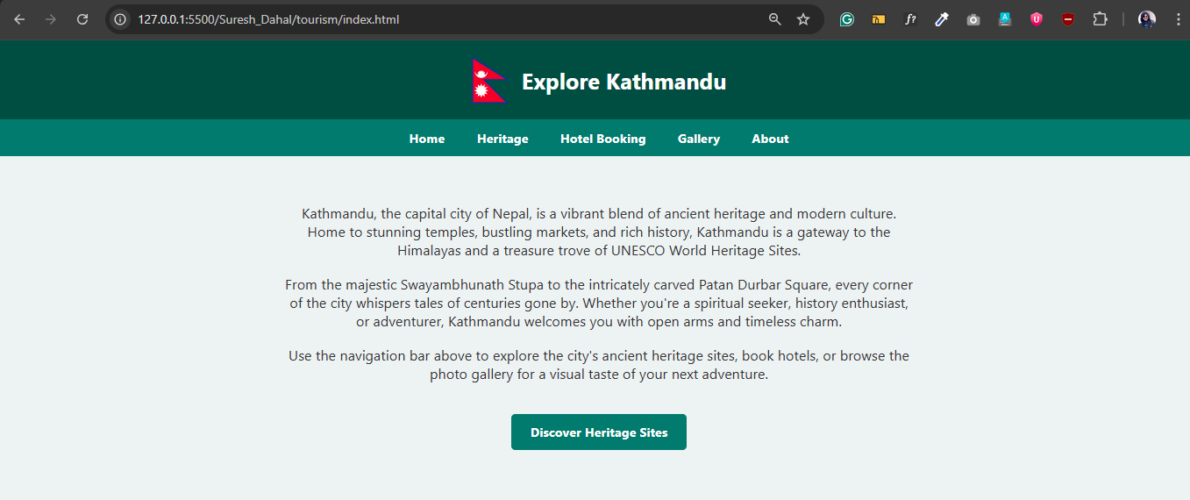

**Heritage.html**

<div class="content">

<h2>Famous Heritage Sites of Kathmandu</h2>

<ul class="heritage-list">

<li>

<a href="swayambhunath.html">

<img src="images/swayambhu.jpg" alt="Swayambhunath">

Swayambhunath

</a>

</li>

<li>

<a href="patan-durbar.html">

<img src="images/patan.jpg" alt="Patan Durbar Square">

Patan Durbar Square

</a>

</li>

<li>

<a href="pashupatinath.html">

<img src="images/pashupati.jpg" alt="Pashupatinath Temple">

Pashupatinath Temple

</a>

</li>

<li>

<a href="bhaktapur-durbar.html">

<img src="images/bhaktapur.jpg" alt="Bhaktapur Durbar Square">

Bhaktapur Durbar Square

</a>

</li>

<li>

<a href="boudhanath.html">

<img src="images/boudhanath.jpg" alt="Boudhanath Stupa">

Boudhanath Stupa

</a>

</li>

<li>

<a href="panauti.html">

<img src="images/panauti.webp" alt="Panauti">

Panauti

</a>

</li>

<li>

<a href="lumbini.html">

<img src="images/lumbini.jpg" alt="Lumbini">

Lumbini

</a>

</li>

<li>

<a href="kasthamandap.html">

<img src="images/kasthamandap.jpg" alt="Kasthamandap">

Kathmandu Durbar Square

</a>

</li>

<li>

<a href="dakshinkali.html">

<img src="images/dakshinkali.webp" alt="Dakshinkali">

Dakshinkali

</a>

</li>

<li>

<a href="kirtipur.html">

<img src="images/panauti.webp" alt="Kirtipur">

Kirtipur

</a>

</li>

</ul>

</div>

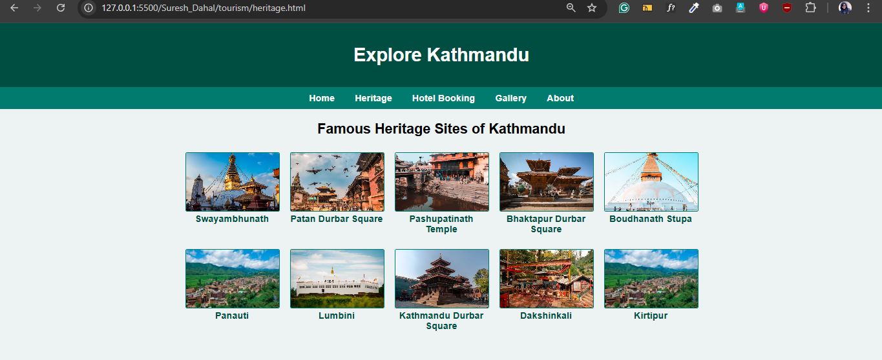

**Swayambhu.html**

<div class="content">

<h2>Swayambhunath Stupa</h2>

<img src="images/swayambhu.jpg" alt="Swayambhunath Stupa">

<p>

Known as the Monkey Temple, Swayambhunath is one of the oldest and most revered Buddhist stupas in Kathmandu. It

sits atop a hill, offering panoramic views of the city.

</p>

<p>

The stupa’s eyes painted on all four sides symbolize wisdom and compassion. Pilgrims and tourists alike visit to

spin prayer wheels, offer prayers, and enjoy the serene surroundings.

</p>

<p>

The site is surrounded by shrines, temples, and monasteries, making it a spiritual hub for Buddhists and Hindus.

</p>

</div>

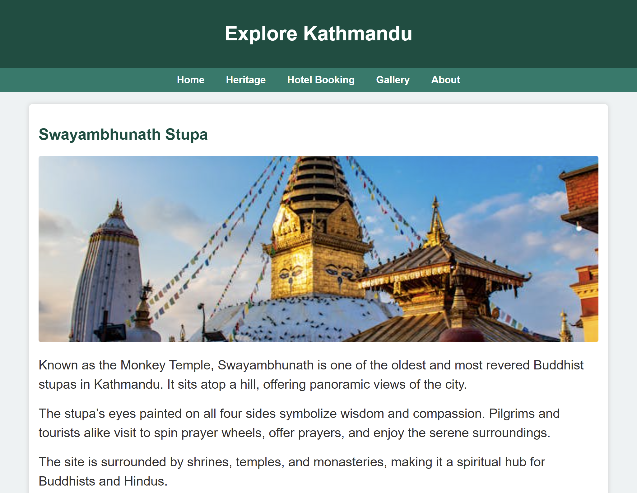

**Patan.html**

<div class="content">

<h2>Patan Durbar Square</h2>

<img src="images/patan.jpg" alt="Patan Durbar Square">

<p>

Patan Durbar Square is a historic plaza in Lalitpur, famous for its Newari architecture, ancient palaces,

and

temples. It was the royal palace of the Malla kings and showcases exquisite craftsmanship.

</p>

<p>

The square is home to the Krishna Mandir, Bhimsen Temple, and Hiranya Varna Mahavihar (Golden Temple),

attracting

tourists and devotees alike. It is a UNESCO World Heritage Site that reflects the rich cultural heritage of

Nepal.

</p>

<p>

Patan Durbar Square hosts many cultural events and festivals throughout the year, preserving traditional art

and

architecture.

</p>

</div>

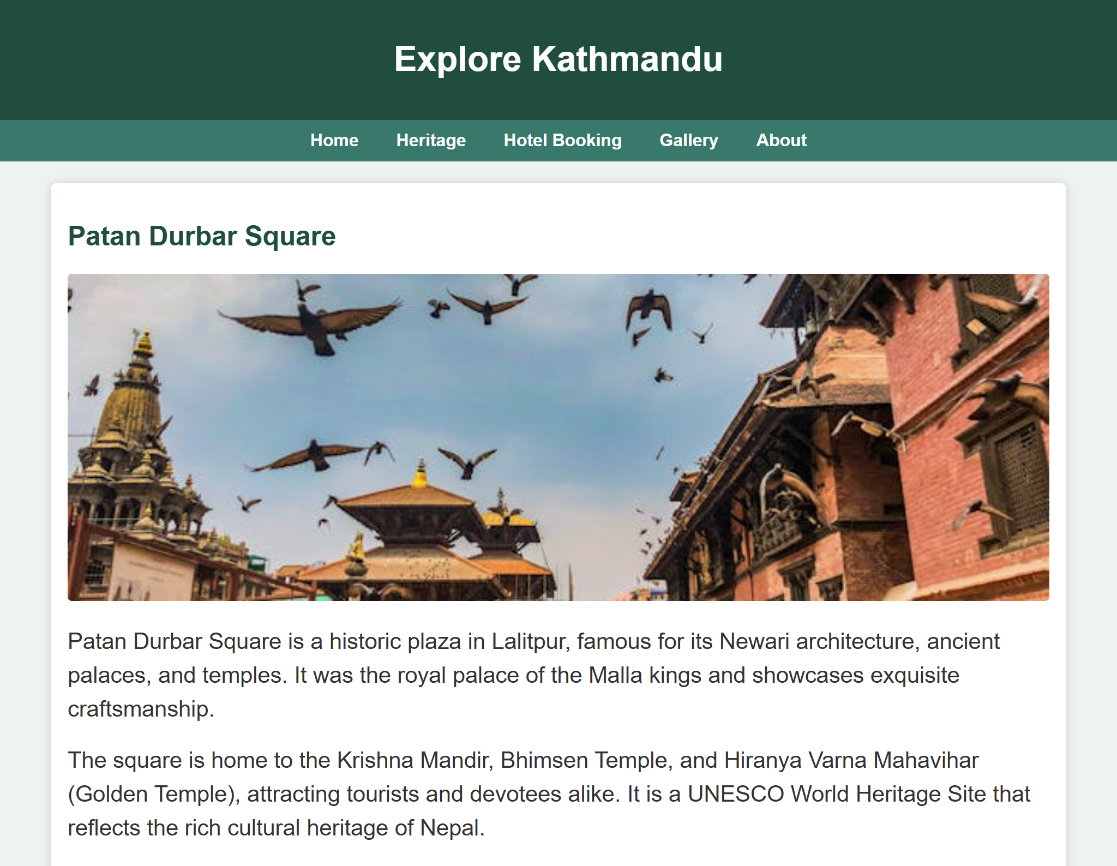

**Lumbini.html**

<div class="content">

<h2>Lumbini</h2>

<img src="images/lumbini.jpg" alt="Lumbini Sacred Garden">

<p>Lumbini, the birthplace of Lord Buddha, is a UNESCO World Heritage Site located in the Rupandehi District of Nepal. It is one of the most important pilgrimage sites for Buddhists around the world. The site includes the Maya Devi Temple, which marks the exact spot where Buddha was born in 623 BC.</p>

<p>The sacred garden surrounding the temple is a serene place for meditation and reflection, with beautiful ponds and ancient ruins. Visitors can also explore the Lumbini Museum, which houses artifacts related to Buddha's life and teachings.</p>

<p>In addition to its spiritual significance, Lumbini is also a center for Buddhist studies and research, attracting scholars and monks from various countries. The peaceful atmosphere and historical importance make Lumbini a must-visit destination for anyone interested in Buddhism and its rich heritage.</p>

</div>

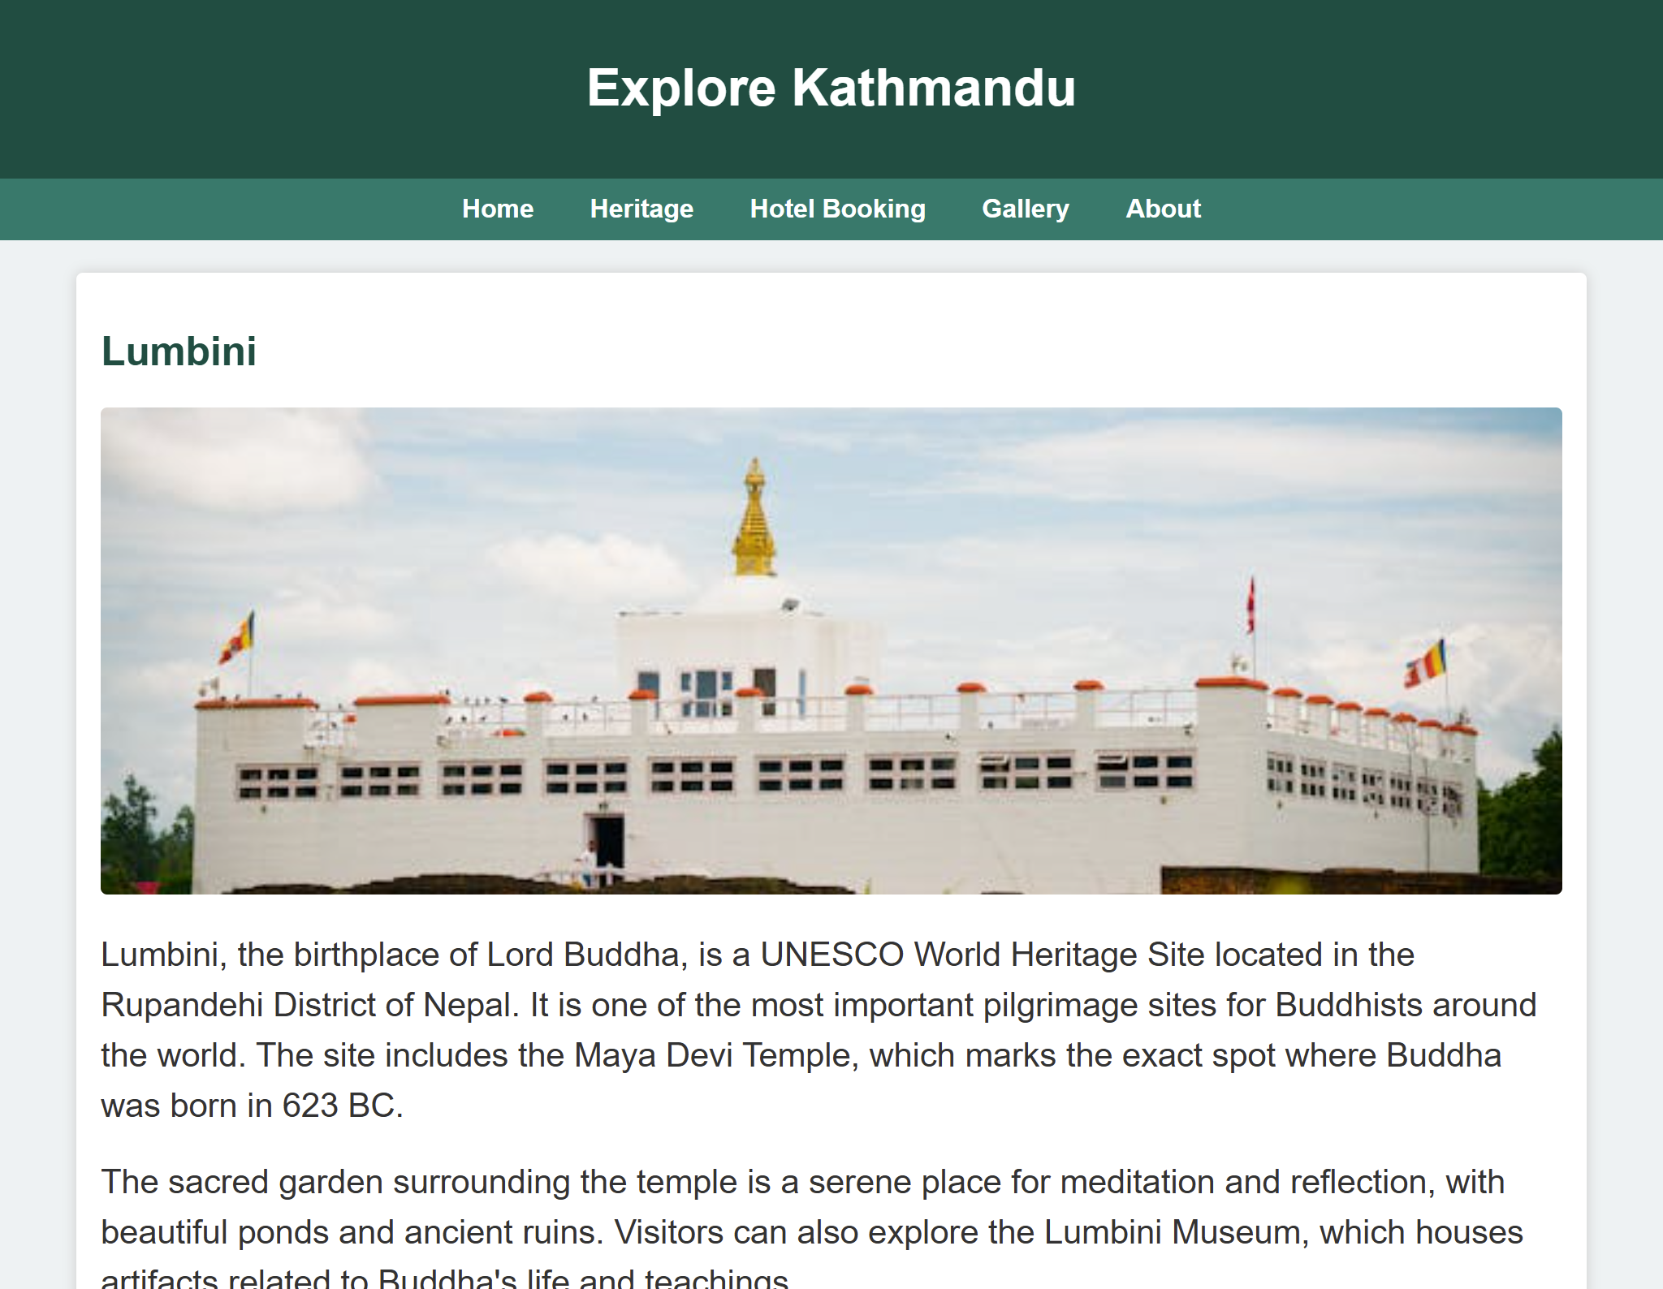

**Boudhanath.html**

<div class="content">

<h2>Boudhanath Stupa</h2>

<img src="images/boudhanath.jpg" alt="Boudhanath Stupa">

<p>

Boudhanath Stupa, located in Kathmandu, is one of the largest spherical stupas in Nepal and a UNESCO World

Heritage Site. It is a significant pilgrimage site for Buddhists around the world and symbolizes peace,

compassion, and enlightenment.

</p>

<p>

The stupa dates back to the 14th century and features a massive mandala on its base. Devotees walk around

the stupa clockwise, spinning prayer wheels and chanting mantras. The site is surrounded by monasteries,

shops, and cafes, creating a vibrant spiritual atmosphere.

</p>

<p>

Boudhanath has survived multiple earthquakes and remains a symbol of resilience and spiritual heritage for

Nepal. It attracts both locals and tourists who seek tranquility and cultural immersion.

</p>

</div>

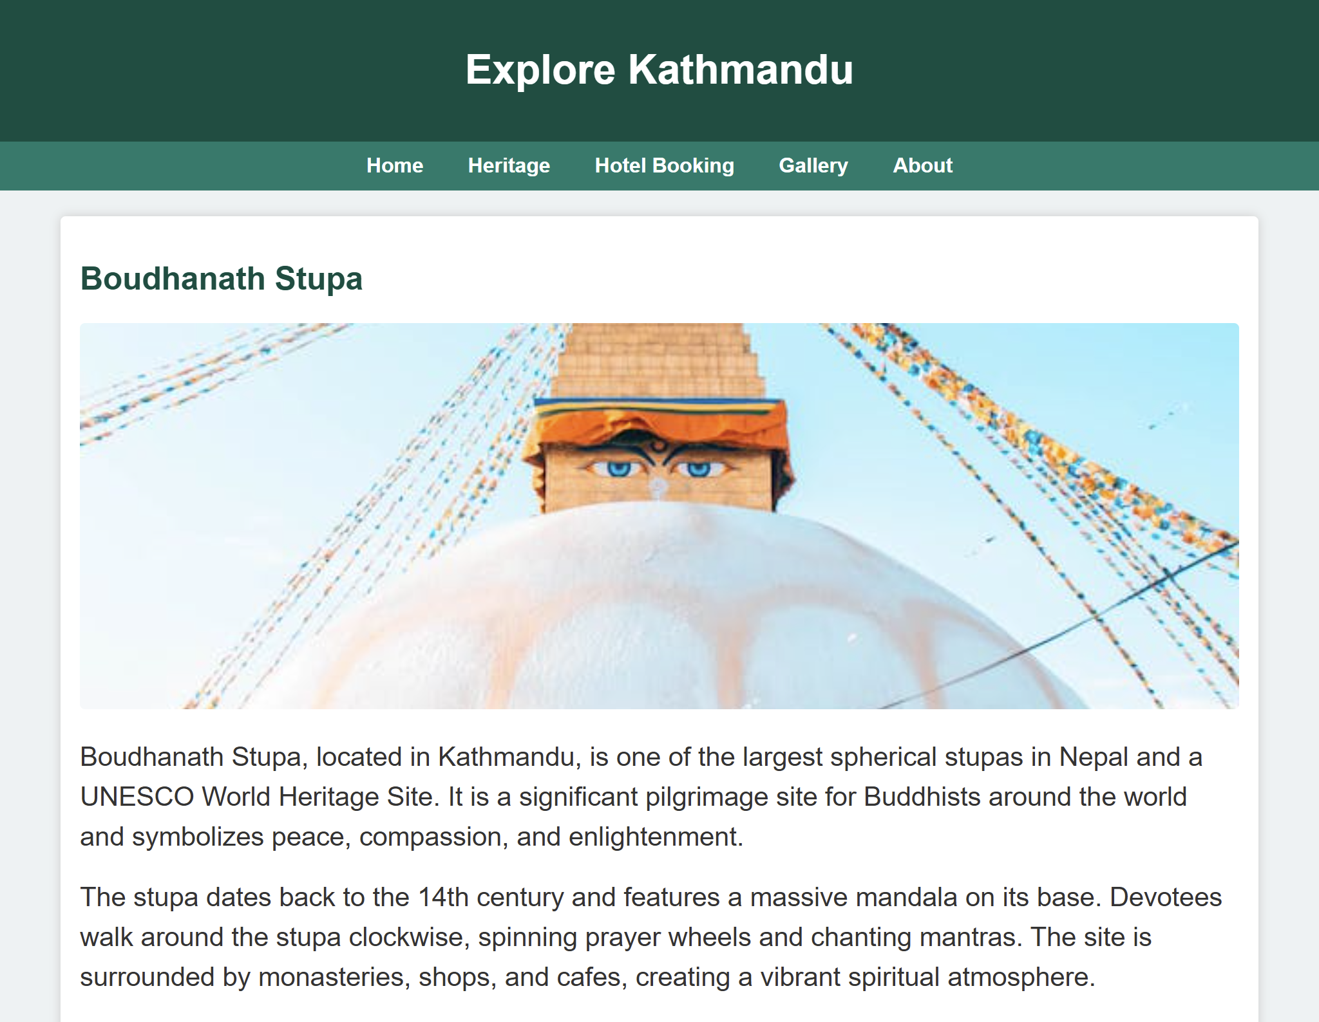

**Panauti.html**

<div class="content">

<h2>Panauti</h2>

<img src="images/panauti.webp" alt="Panauti">

<p>

Panauti is a small ancient town near Kathmandu known for its well-preserved temples, cultural heritage, and

traditional Newari architecture.

</p>

<p>

The town hosts several festivals including the Panauti Jatra, featuring chariot processions and rituals. It’s a

quiet getaway spot offering insights into Nepal’s rural traditions.

</p>

<p>

Visitors can explore temples such as Indreshwar Mahadev and enjoy the serene environment along the Roshi River.

</p>

</div>

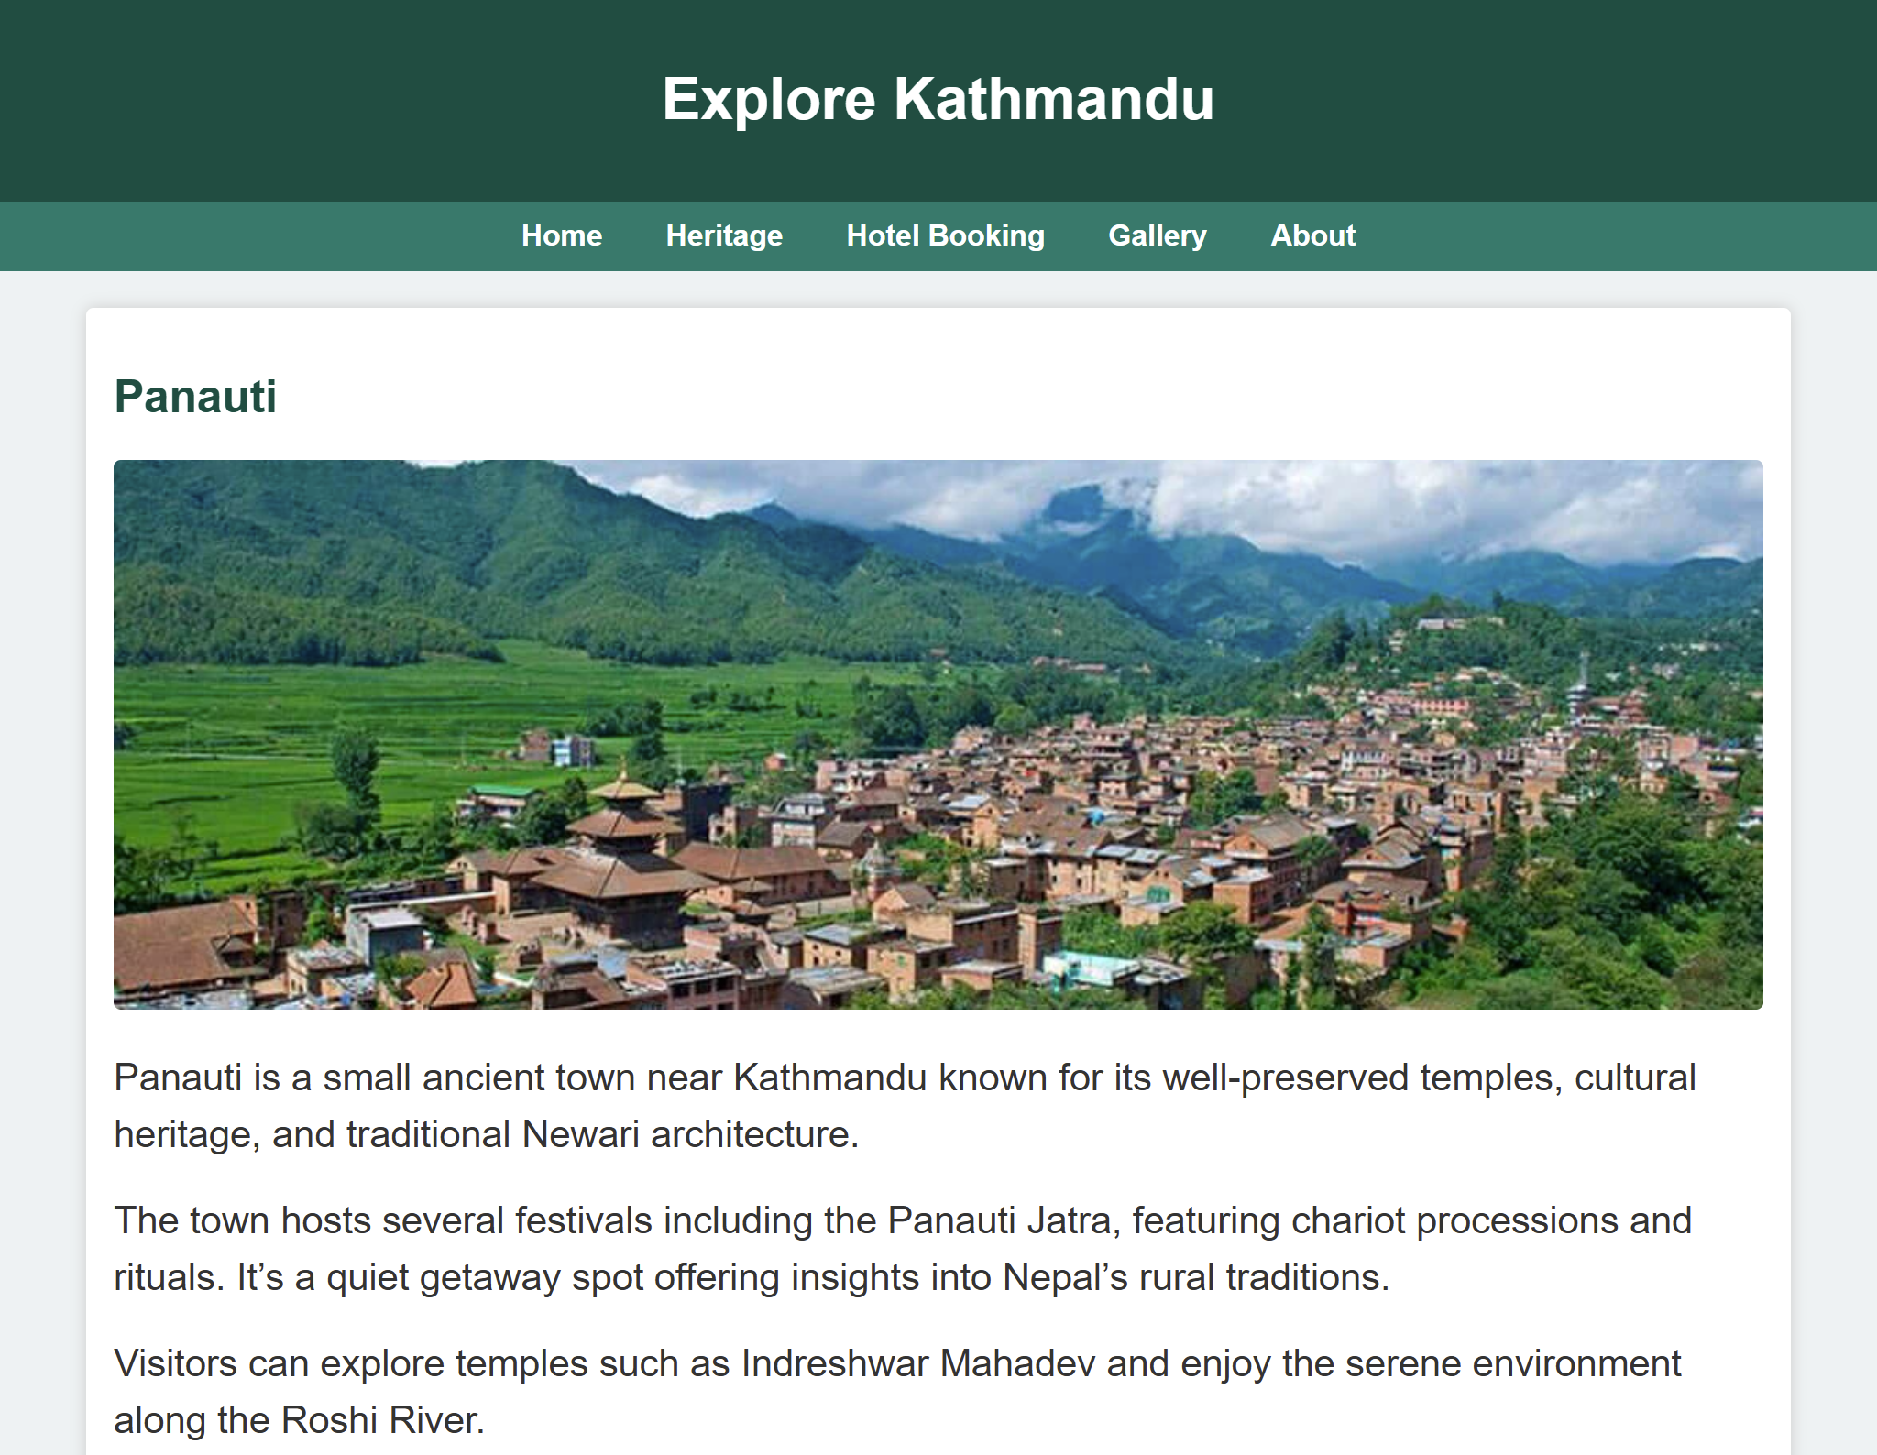

**Hotel.html**

<main>

<h2>Hotel Booking Form</h2>

<form action="#" method="post">

<table>

<tr>

<td>

<label for="fullname">Full Name</label>

<input type="text" id="fullname" name="fullname" required />

</td>

<td>

<label for="email">Email</label>

<input type="email" id="email" name="email" required />

</td>

</tr>

<tr>

<td>

<label for="phone">Phone Number</label>

<input type="tel" id="phone" name="phone" pattern="[0-9]{10,15}" required />

</td>

<td>

<label for="currency">Currency</label>

<div style="display: flex; gap: 10px; justify-content: start; width: fit-content;">

<input type="radio" name="currency" id="npr" value="NPR" checked />

<label for="npr">NPR</label>

<input type="radio" name="currency" id="usd" value="USD" />

<label for="usd">USD</label>

</div>

</td>

</tr>

<tr>

<td>

<label for="checkin">Check-in Date</label>

<input type="date" id="checkin" name="checkin" required />

</td>

<td>

<label for="checkout">Check-out Date</label>

<input type="date" id="checkout" name="checkout" required />

</td>

</tr>

<tr>

<td>

<label for="roomtype">Room Type</label>

<select id="roomtype" name="roomtype" required>

<option value="">Select...</option>

<option value="single">Single</option>

<option value="double">Double</option>

<option value="suite">Suite</option>

</select>

</td>

<td>

<label for="guests">Number of Guests</label>

<input type="number" id="guests" name="guests" min="1" max="10" required />

</td>

</tr>

<tr>

<td colspan="2">

<label for="requests">Special Requests</label>

<textarea id="requests" name="requests" rows="3"

placeholder="Any special requirements?"></textarea>

</td>

</tr>

<tr>

<td colspan="2" style="text-align:center;">

<input type="submit" value="Book Now" />

</td>

</tr>

</table>

</form>

</main>

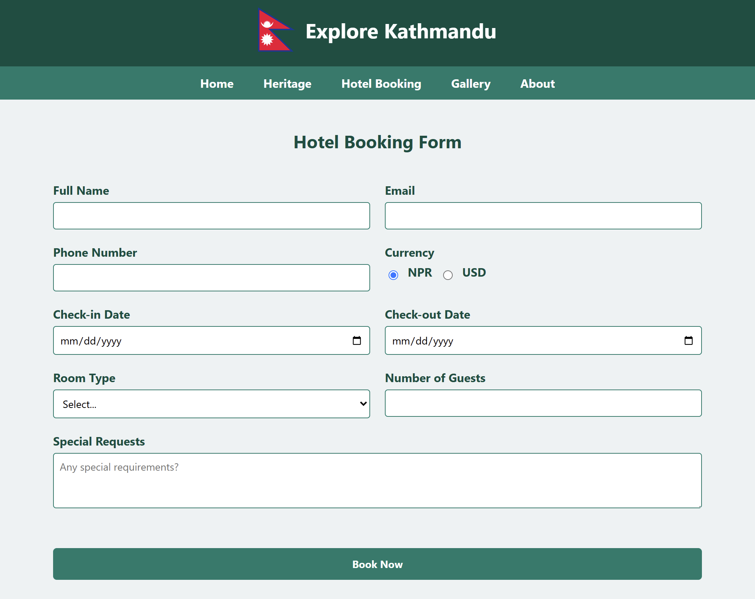

**Gallery.html**

<div class="content">

<h2>Photo Gallery</h2>

<div class="gallery">

<div>

<img src="./images/swayambhu.jpg"

alt="Swayambhunath">

<div class="caption">Swayambhunath</div>

</div>

<div>

<img src="images/boudhanath.jpg"

alt="Boudhanath">

<div class="caption">Boudhanath Stupa</div>

</div>

<div>

<img src="./images/patan.jpg"

alt="Patan Durbar Square">

<div class="caption">Patan Durbar Square</div>

</div>

<div>

<img src="./images/kasthamandap.jpg"

alt="Kathmandu Durbar Square">

<div class="caption">Kathmandu Durbar Square</div>

</div>

<div>

<img src="./images/pashupati.jpg"

alt="Pashupatinath">

<div class="caption">Pashupatinath Temple</div>

</div>

<div>

<img src="./images/changunarayan.jpg"

alt="Changunarayan">

<div class="caption">Changu Narayan</div>

</div>

</div>

</div>

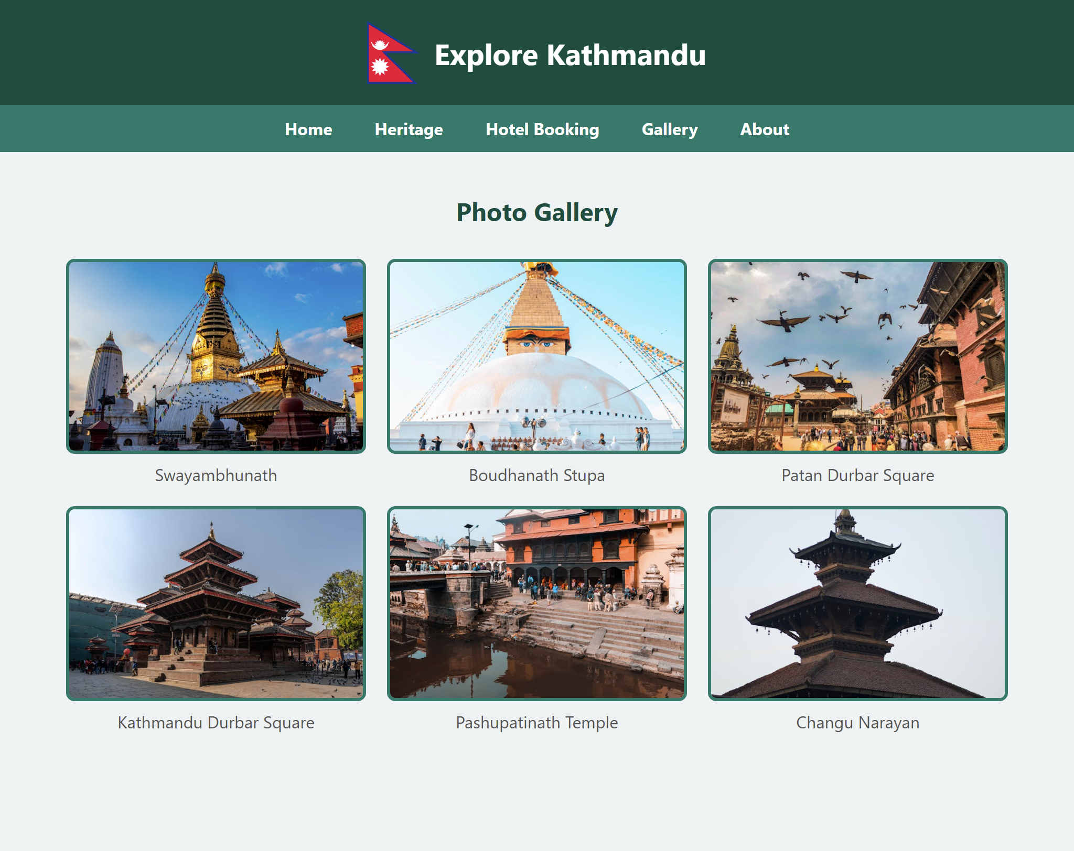

**About.html**

<div class="content">

<h2>About Us</h2>

<p>

Welcome to Explore Kathmandu — your guide to the historical heart of Nepal.

Our mission is to showcase the rich cultural and spiritual heritage of Kathmandu and promote sustainable

tourism.

</p>

<p>

Whether you're seeking ancient temples, vibrant festivals, or peaceful spiritual retreats,

Kathmandu offers something truly unique. Through this website, we aim to help both local and international

tourists

explore the wonders of the city, plan their visits, and appreciate its timeless beauty.

</p>

<p>

We are a team of culture enthusiasts, designers, and travelers committed to preserving and promoting

the heritage that makes Kathmandu unforgettable.

</p>

</div>

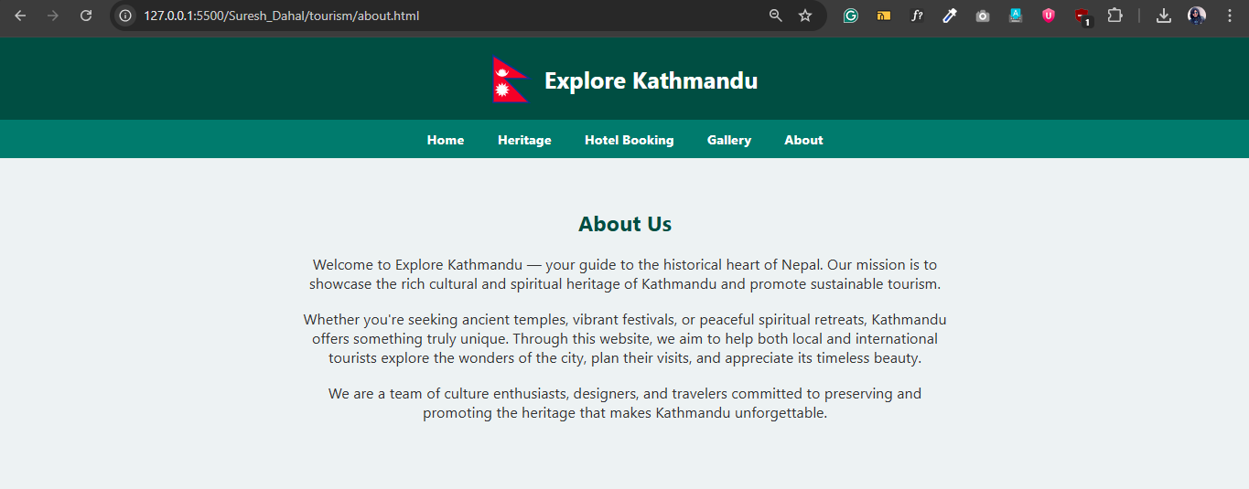

**Style.css**

body {

margin: 0;

font-family: 'Segoe UI', Tahoma, Geneva, Verdana, sans-serif;

background-color: #eef2f3;

}

header {

background-color: #004d40;

color: white;

padding: 20px 0;

text-align: center;

}

header img {

height: 60px;

vertical-align: middle;

margin-right: 10px;

}

header h1 {

display: inline-block;

font-size: 28px;

margin: 0;

vertical-align: middle;

}

nav {

background-color: #00796b;

text-align: center;

}

nav a {

color: white;

display: inline-block;

padding: 12px 18px;

text-decoration: none;

font-weight: bold;

}

nav a:hover {

background-color: #004d40;

}

.content {

padding: 40px;

text-align: center;

}

.content p {

font-size: 18px;

max-width: 800px;

margin: 20px auto;

color: #333;

}

.btn {

display: inline-block;

background-color: #00796b;

color: white;

padding: 12px 24px;

text-decoration: none;

border-radius: 5px;

font-weight: bold;

}

.gallery {

display: flex;

flex-wrap: wrap;

justify-content: center;

gap: 20px;

} .gallery img {

width: 280px;

height: 180px;

object-fit: cover;

border: 3px solid #00796b;

border-radius: 8px;

background-color: white;

}

.caption {

font-size: 16px;

color: #555;

margin-top: 5px;

}